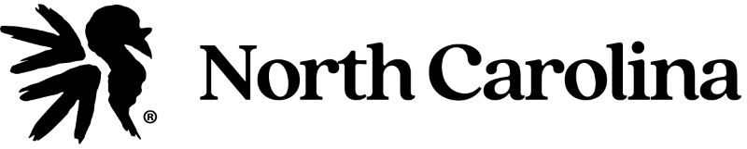

2024 NC-NWTF TARHEEL OPEN DDC CALLING CONTEST
(ALL CALLERS MUST PROVIDE PROOF OF NWTF MEMBERSHIP)

Date: Saturday, March 2, 2024
Location: NC State Fairgrounds Raleigh, NC Contest
Registration: 8:30 am – 9:30 am inside Jim Graham Building
Callers Meeting: 9:45 am
Contests Begin: 10:00 am

Entry Fees and Order of Contests

Please check the division(s) that you plan to call in:

o Poults: 9 and under Free o Jakes: 10 to 15 yrs. $10.00
o Intermediate: 16 to 20 yrs. $25.00 o Tarheel Open: 21 yrs and older $50.00
o Tarheel Resident: 21 yrs and older $50.00 o Friction: 21 yrs and older $50.00
o Natural Voice: All Ages $25.00 o Owl Hooting: All ages $25.00
o Gobbling: All ages $25.00

Calls will be posted day of contest

Please return this form along with the correct fees no later than February 20, 2024 and receive a 10% discount. Send forms to: Robert Smith @ 105 Glencroft Rd, Hubert NC 28539

You can email or call Brent Phillips at: bphillips@billblackauto.com 336-451-4099

This is an NWTF sanctioned contest and all local contest rules will apply.

Cash and/or Prizes awarded for 3 places in all contests
NWTF Member ID #: ___________________________________________________
Name: _________________________________________________________________
Address:_______________________________________________________________
City: ________________________ State:______________ Zip:___________________
Phone: ______________ Email:___________________________________________
Date of Birth: (Month and Year only) ______________________________________

